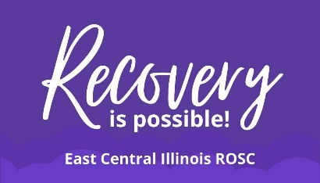
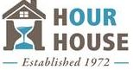

Effingham County Free Narcan locations
Available to the public, no questions asked.
To become a DOPP site, contact:
Samantha Hicks @ 217-663-0823 or samanthah@hourhouserecovery.org

Effingham Public Library- 200 N. 3rd St, Effingham, IL 62401
Hazel-Jayne- 112 E. Section Ave, Effingham, IL 62401
Live-in Cosmetics- 1707 Ave of Mid America Suite C, Effingham, IL 62401
Village Square Mall- 1901 S. Banker St, Effingham, IL 62401

