Recovery Community Cookout
If you or someone you know is in recovery or is interested in recovery from substance or alcohol use, this cook out is for you!
Please join the Piatt County ROSC Council Sunday, September 25th from 12:30 pm to 4:00 pm at the Monticello Forest Preserve Park to celebrate you!

This is a family event so please bring the family to enjoy face painting, fair games, demonstrations from HMD Tae Kwon Do Academy and Jade Fortress Kung Fu and food cooked by our grill master Aaron Donaldson!
We will also have bags and kickball!
Don’t be a stranger, come celebrate your recovery and have some fun! #ILRecoveryBelongs
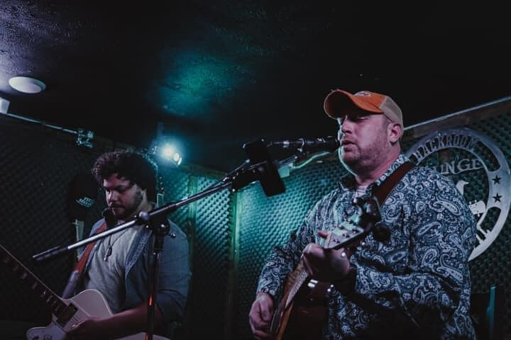
Leigh Ewers Sarah Henry
LIVE MUSIC BY
