Creating Your Communication & Outreach Plan
Follow the steps outlined below (adapted from the Healthy Start Grantee 2016 Communication and Outreach Toolkit) to help you develop a tailored workplan and assist you in setting and reaching your communication goals for this grant project and beyond. It may be helpful to create a communications committee and set regular meeting dates and times.
Step 1: Project Goals and Objectives (SMART Objectives)
What are your communication plan goals and objectives? Describe what you are trying to achieve. Outline a specific, tangible goal that will become the framework of your plan. Considering the overarching goal of your project, if you were successful what would it look like? Objectives should be SMART: Specific, Measurable, Attainable, Relevant, and Time-bound. The following link is a resource for creating smart objectives.
https://www.cdc.gov/healthyyouth/evaluation/pdf/brief3b.pdf

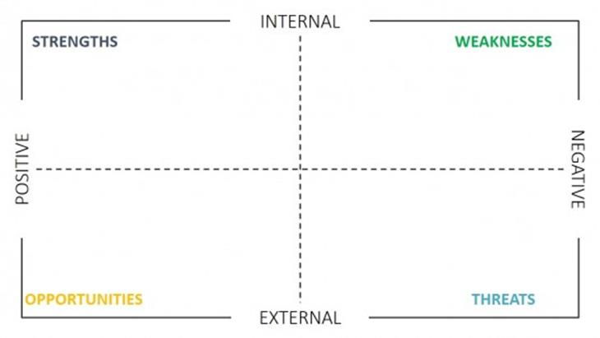Step 2: SWOT Analysis
SWOT analysis involve listing your strengths, weaknesses, opportunities, and threats. Think about what this means in terms of your communications priorities. How can threats be turned into opportunities? How can you play on your strengths through effective communications?
https://www.cdc.gov/healthyyouth/evaluation/pdf/brief3b.pdf
Step 3: Identify your Audiences
Who are your target audiences? What are their beliefs about Substance Use Disorder, Recovery, and ROSC? List your audiences and your communication goal for each audience.
Audience | Communication Goal
SUD/MH Providers in our ROSC Region | All providers in our area are aware of our efforts to initiate the new ROSC Council and know how they can be involved
Step 4: Prioritize your target audiences
- First - Rank each audience in terms of their importance to your work: not applicable, somewhat important, and critically important.
- Next – Choose your five most critical audiences. Once you have ranked the audiences you will have a clear understanding of the target audiences you need to reach.
Step 5: Communication Channels
Consider all the possible venues for outreach and select the options that make the most sense for this message and its audience. For example, for parents, an ad or an article in the school bulletin may be more effective than a similar placement in the local newspaper because it targets parents specifically.
Step 6: Timeline
Choose your timeline based on your resources such as staffing, budget, access to target audience for messaging. Your overall communication plan should have a timeframe and each of your S.M.A.R.T. objectives will have timeframes. Differentiate what you can implement immediately, what will happen over the course of the project, and what will need to happen after the grant timeline.
Step 7: Budget
Create a communication and outreach budget. Leverage your resources by looking for/building on existing events where you can reach your key audience. Do you want to attend a radio show or hold a press conference? What materials (brochures, flyers, and posters) would help support your communication efforts? A small flier might help spread your message at a community meeting, and a poster might be more useful at medical offices. Think about a high traffic area where your target audience might see your materials. A Communication and Outreach Budget will also help you differentiate what resources you currently have for this and what you may need to include in your strategic plan and sustainability efforts for moving forward.
Step 8: Implement
Once you’ve selected your activities and developed specific goals work to assign dates, materials, budget, and the staff/volunteers needed to achieve those goals. Develop a Communication and Outreach work plan for you to use as a tool to get organized and stay on track.

