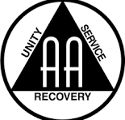
YOU ARE NOT ALONE!

ALCOHOLIC ANONYMOUS
SUPPORT GROUP
PLEASE JOIN US IN PERSON:
EVERY MONDAY @ 6:00 – 7:00PM
TAKE ACTION TODAY CENTER
809 W. MAIN ST.
CARBONDALE, IL

