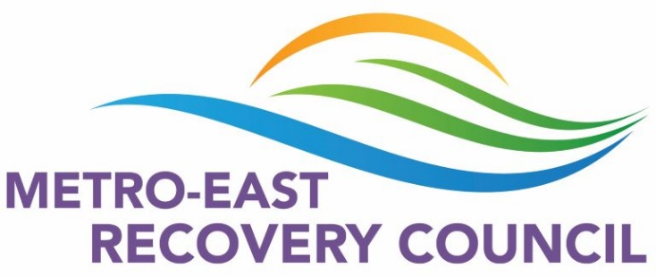
MERC Meeting Minutes
October 21, 2021
9am Zoom
- We welcomed 29 members to our October meeting.

Old Business
- Mental Health Walk, St. Clair County – Family Support Network folders were available, walk was successful.
- Community Wellness Project Health Fair, St. Clair County – handed out a lot of FSN folders and other giveaways with information.
- Keri Wright is no longer with MERC. We thank her for her previous service to this council. Please contact Terri McKee at tlmckee@chestnut.org for MERC after October 25, 2020.
- Narcan Virtual Training at 10am & 2pm on October 21st .
New Business
- Executive Board – Requested MERC members consider serving in this capacity.
- Memorandum of Understanding (MOU) – Attached to this e-mail, please review, sign, and return to Terri McKee at tlmckee@chestnut.org at your earliest convince.
- Events at SWIC and SIUE this fall – having comfort dogs, giveaways to hand out, as well as coffee and donuts. Please reach out if you are willing to help with the events or have contacts that could help with these things.
Liz at: eamcquaid@chestnut.org or Terri at: tlmckee@chestnut.org
- 10/23 Drug Take Back Day – encourage everyone to clean out their medicine cabinets and ask their family and friends to do so also. Go to DEA Take Back website for locations near you. Take Back Day (dea.gov)
- Diana Cuddeback, LCSW and the Founding Director of Heartlinks Grief Center in Belleville, presented about what Heartlinks offers.
- Sonja Vauters presented a wellness moment to the council.

Next meeting: November 18, 2021 9:00 am via Zoom. Link will be e-mailed the day before.

