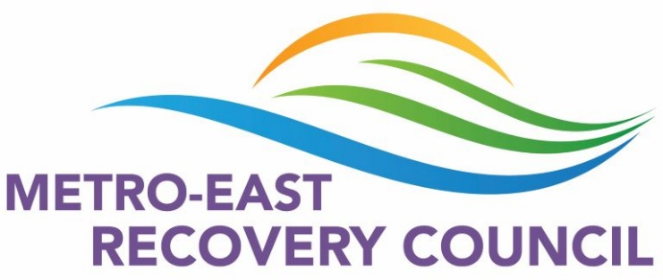
MERC Meeting Minutes
September 16, 2021
9am Zoom
- We welcomed 24 members to our September meeting.
Old Business
- Laura Schumacher is no longer with Chestnut/MERC. We thank her for her previous service to this council.
- Recovery Month
- August 31st Bond County Overdose Awareness Event- MERC was represented at this event and recovery information was made available to the public.
- September 1st Clinton County Overdose Awareness Event- MERC was represented at this event and recovery information was made available to the public.
- September 1st Library displays have been set up in Alton, Troy, Belleville, Edwardsville, Dupo, and O’Fallon. They include books and information about recovery.
- September 10th Madison County Suicide Awareness Event- MERC was represented at this event and recovery information was made available to the public.
- September 11th “Rockin’ for Recovery”- MERC was represented at this event and NARCAN was handed out as well as information about recovery.
- September 12th “Countywide Day of Prayer”- Over 35 faith based organizations were contacted as well as several ministerial alliances and asked to include people in recovery and their families and friends in prayers this month.
New Business
- Deborah Humphrey MBA, BSN, RN, Executive Director of the Madison County Mental Health Board presented about the roles and responsibilities of the 708 board.
- Sonja Vauters shared information about the Walk for Mental Health and presented a wellness moment to the council.
Upcoming Events
- September 23rd “Facebook Live Event” featuring a panel with Toni Randall, Mark Sanders, and Ty Bechel at 7pm. Panel members will discuss different perspectives of Substance Use Disorder and recovery.
- October 21st Narcan Virtual Training at 10am & 2pm.
- October 16th Walk for Mental Health at 10am in Fairview Heights at Moody Park.
- Family Support Network Zoom meeting Wednesday, October 6th at 10am.
- Partnership for Drug-Free Communities Zoom Meeting Wednesday, September 22nd at 10am. Paul Cook, Parenting Coach, will presenting “Reinforcing The Need To Get Parents In The Community More Involved In Drug Prevention”. https://www.paulcooktalks.com/
- Oct 23rd is National DEA Drug take back day Take Back Day (dea.gov)
Next meeting: Oct. 21, 2021 9:00 am via Zoom. Link will be e-mailed the day before.

